Network Security Assignment 2

VIDIT PRASHANT GALA
252IS012

Analysis of Vulnerabilities Across Network Layers Using a Layered Security Model

Setup:
VMWare Workstation - Virtual Machine
1 Virtual Machine for the attacker (KALI) - 192.168.65.129
1 Virtual Machine for the victim (KIOPTRIX) - 192.168.65.128
Both machines will be connected to the host only settings, so the Virtual Machines will be different but we can attack on the victim (kioptrix) using kali linux.

OSI Layer
1. Physical Layer -
Attacks - Ethernet Cable Disconnection
Ethernet Cable Disconnection is an attack in which the attacker unplugs the ethernet cable from the system or from the router directly. A lot of packet loss can occur during this attack.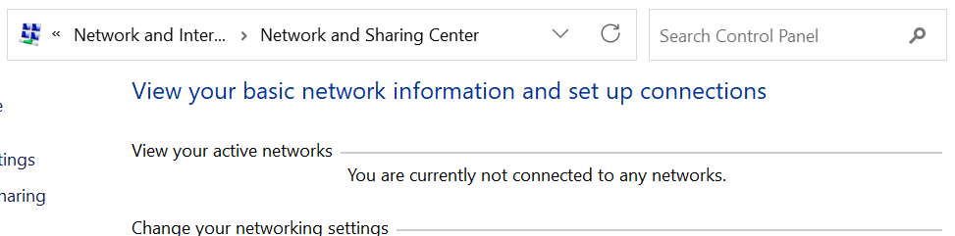
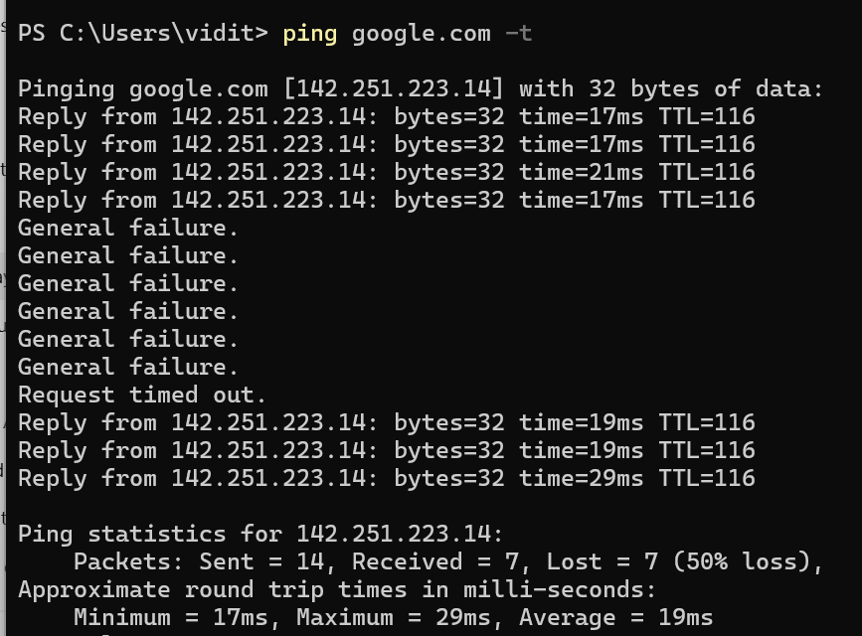
Impact Analysis -
Before the attacker attacks the system, the internet connection was working properly, once attacker attacks we can see a failure which then leads to loss of packets and thus we see that there was a 50% loss of packets. All network services failed instantly despite correct software configuration.
Mitigation Strategies -
- Secured Cable Routing - Protecting cable routes by concealed pipes or by managed wiring.
- Network Link Monitoring - Detects physical link failures quickly and enables a quick response to physical disruptions
2. Data Link Layer -
Attacks - ARP Spoofing
ARP Spoofing is an attack in which an attacker uses a spoofing tool to send ARP forged responses which then forces the router and the workstation to connect to the attacker’s machine instead with each other.
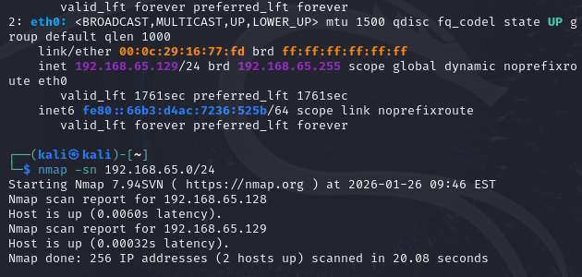
We first look for different IPs present from the attacker side(129.168.65.129), and we find out that a host is up(129.168.65.128). We will send ARP forged responses to this victim.
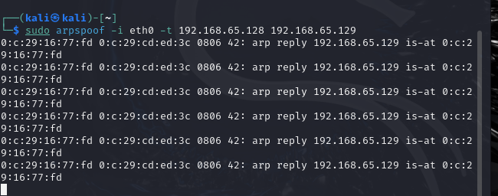
sudo tcpdump -i eth0 arp - This command is for sending arp forged packets from the attacker side to the victim while the connection is there.
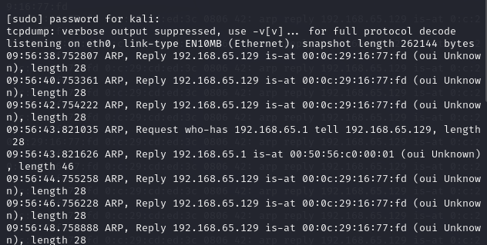
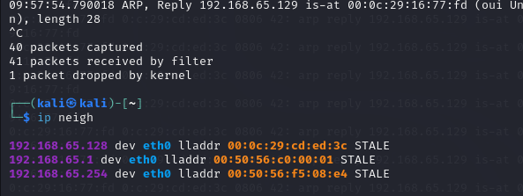

Impact Analysis -
By performing ARP spoofing, the attacker successfully poisoned the victim (Kioptrix) ARP cache, causing it to associate the attacker’s MAC address with a trusted host IP. As a result, the victim’s network communication became dependent on the attacker, allowing traffic observation and potential disruption. This demonstrates how a victim host can lose trust in correct IP–MAC mappings without any visible warning.
Mitigation Strategies -
- Static ARP Entries - Configure static ARP mappings for critical hosts so that IP–MAC associations cannot be altered dynamically by spoofed ARP replies.
- ARP Spoofing Detection Tools - Deploying ARP monitoring or intrusion detection mechanisms can detect abnormal ARP replies and alert administrators to spoofing attempts.

3. Network Layer -
Attacks - IP Spoofing / DOS
IP Spoofing is an attack in which an attacker uses a spoofed IP address to send packets to a victim and thus tricks the victim by sending malicious packets. While the victim will think they are receiving packets from a legitimate user.
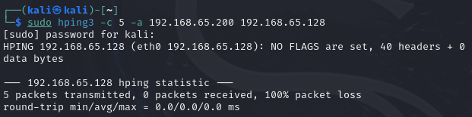
192.168.65.200 is a forged IP address, while 192.168.65.129 was its original IP address. Attacker sends 5 packets to the victim.
DOS (denial of service) attack is an attack in which a network/website/system is made unavailable by sending packets in an overwhelming way causing the network to slow down or crash.
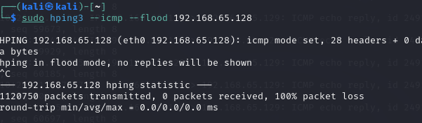
Icmp flood <victim> - This command floods <victim-ip> with many packets.
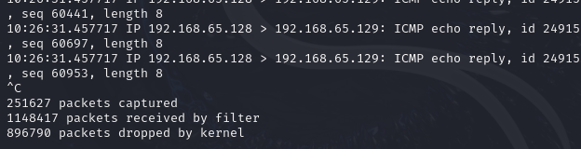
251627 packets were captured by the victim, this causes the system to slow down
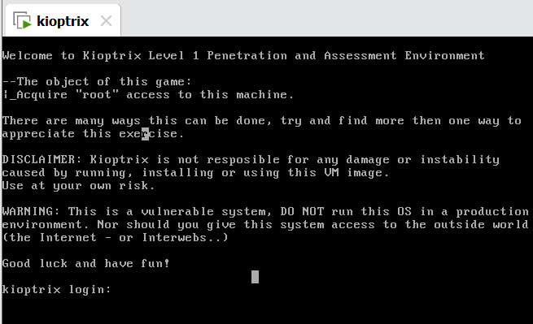
Impact Analysis -
IP spoofing -
The attacker successfully sent packets to the victim (Kioptrix) using a forged source IP address. This shows how a victim can be misled about the true origin of network traffic, enabling impersonation and trust-based attacks.
DOS-
During the DoS attack, the victim was flooded with a large number of ICMP packets, consuming network and system resources. This caused degradation in normal communication and made the victim system slow or unresponsive. The experiment demonstrates how excessive traffic can disrupt availability without exploiting software vulnerabilities.
Mitigation Strategies -
- Authentication at Higher Layers - Using secure protocols with authentication (e.g., SSH, TLS) ensures that even if IP addresses are spoofed, the attacker cannot establish trusted communication.
- Rate Limiting and Traffic Filtering - Limiting the number of packets accepted per second helps prevent resource exhaustion caused by flooding attacks.
- Intrusion Detection / Prevention Systems (IDS/IPS) - Monitoring abnormal traffic patterns allows early detection and automatic blocking of DoS attempts.

4. Transport Layer -
Attacks - Port scanning
Port scanning attack is a type of attack in which attackers look for open ports in the victim's system and then try to scan for vulnerabilities or finding security weaknesses.
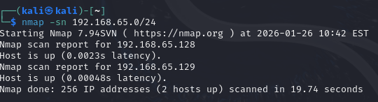
We look for hosts in the same network, and find that 192.168.65.128 does exist in the same network so this becomes the victim.
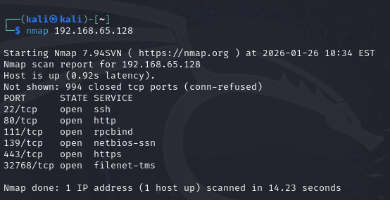
nmap <victim-ip> - This command looks for open ports present in the victim’s system.
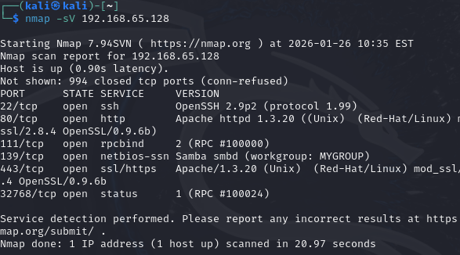
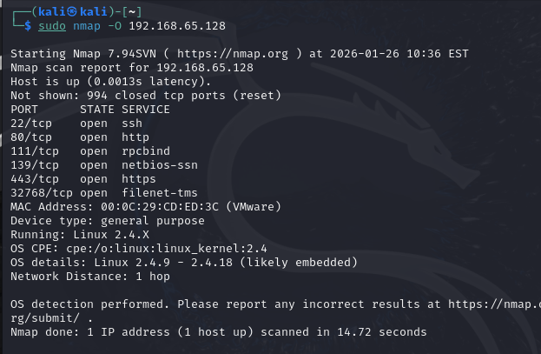
sudo nmap -O <victim-ip> - This command gives details such as the OS version, open ports, network details, etc about the victim’s system.
Impact Analysis -
By performing port scanning on Kioptrix, the attacker was able to identify open ports and active network services without authentication. This exposed information about the system’s service configuration and potential entry points. Such reconnaissance reduces the attack effort required for further exploitation and increases the overall security risk to the victim.
Mitigation Strategies -
- Firewall Configuration - Implement host-based or network firewalls to restrict access to unnecessary ports and allow only trusted IP addresses.
- Port Scan Detection and Monitoring - Use intrusion detection or monitoring tools to identify abnormal scanning activity and alert administrators for timely response.
5. Session Layer -
Attacks - Session Termination (TCP Reset)
Connection Termination (TCP Reset) is an attack in which attackers forcibly end a connection by sending forged packets to interrupt data flow using spoofed IP addresses.
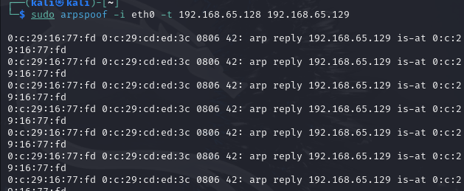
arpspoof -i eth0 -t <victim-ip> <host-ip> - This command sends arp forged packets to the victim-ip.
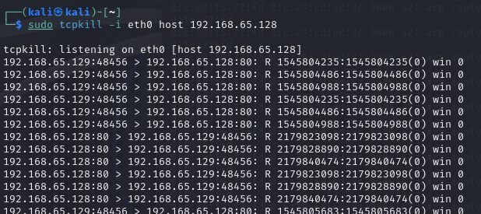
tcpkill -i eth0 host <victim-ip> - This command kills tcp connection abruptly between the two.
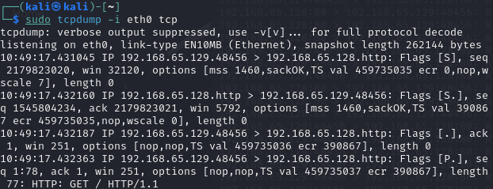
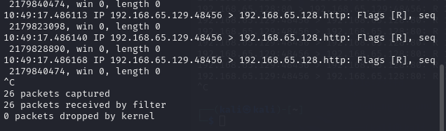
Impact Analysis -
In this attack, forged TCP RST packets were injected into an active TCP connection involving the victim (Kioptrix), causing the connection to terminate abruptly. This disrupted ongoing communication and made network services temporarily unavailable to legitimate users. The experiment demonstrates how an attacker can break active sessions without authentication, affecting the availability of the victim system
Mitigation Strategies -
- Encrypted and Authenticated Connections - Using secure protocols such as TLS or SSH with proper authentication makes it difficult for attackers to inject valid reset packets into active sessions.
- Intrusion Detection and Traffic Filtering - Deploying IDS/IPS or firewall rules to detect abnormal TCP reset patterns can help identify and block malicious connection termination attempts.
6. Presentation Layer -
Attacks - Malicious File Format
Malicious file format attack is a type of attack in which attacker will send malicious PDFs, Word, etc. For a user these files will seem normal and legitimate and thus the attacker forces the victim to execute the files which then leads to activation of malware which then leads to stealing data, corrupting systems, etc.
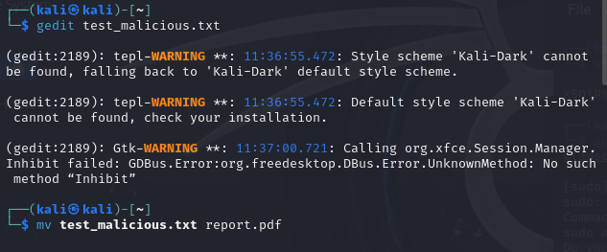
Inserting malicious code in a test file and then converting it to a pdf which is then sent to victims.
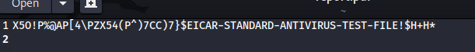
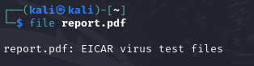
We can see that scanning of this pdf file just shows the written contents of it and not the malicious code.
Impact Analysis -
This attack demonstrates how malicious content can be embedded inside a seemingly legitimate file format such as a document or PDF. When such a file is opened by the victim, it can trigger unintended behavior like malware detection alerts, application crashes, or exploitation of parsing vulnerabilities. The victim is affected because the attack relies on trust in common file formats rather than direct exploitation of network services.
Mitigation Strategies -
- File Content Scanning and Sandboxing - All incoming files should be scanned using antivirus or sandboxing solutions to detect malicious signatures or suspicious behavior before opening.
- Regular Application Updates and Patch Management - Keeping document readers, parsers, and operating systems updated reduces the risk of file-format vulnerabilities being exploited by malicious files.

7. Application Layer -
Attacks - SQL Injection / Buffer Overflow
SQL Injection is an attack in which malicious SQL code is injected into a website’s input field which tricks the website to execute harmful commands and thus attacker can read/manipulate data.
Buffer Overflow attack is an attack in which attacker tries to store more data than is possible in buffer and also sends malicious code in the data they send, and can make the user’s system to crash.
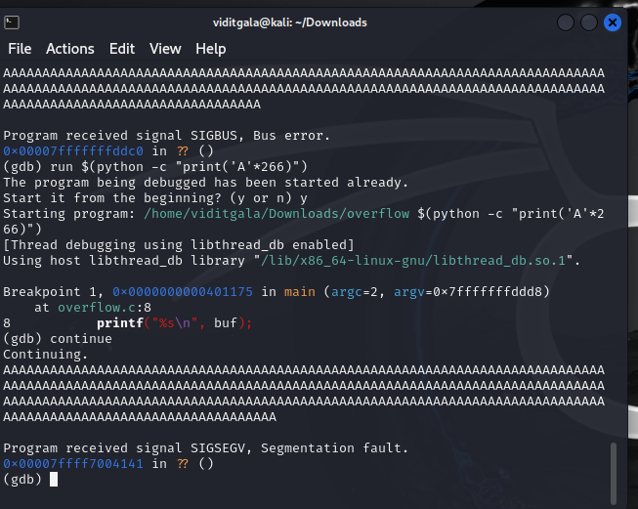
We send 264A’s as input to the system to check if that will overflow the stack space or not and we find that it does overflow the stack space as it gives segmentation fault.

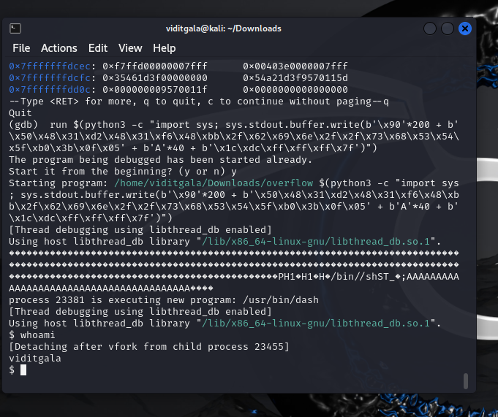
Now we send malicious code as input to the system which will cause the stack space to overflow and then the code executes which will give us entry to the system.
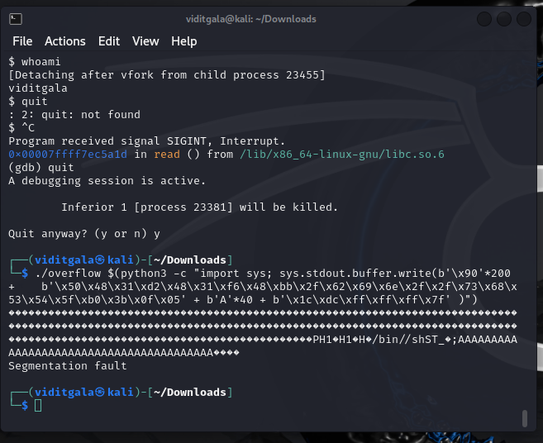
Impact Analysis -
The payload executed successfully and it overflowed the buffer, overwrote the saved return address (RIP), and redirected execution into the NOP sled, eventually running injected /bin/sh shellcode. After this, we typed whoami and got “viditgala”, confirming that the exploit worked and we now have an interactive shell spawned directly from the buffer overflow attack. So the exploit worked.
Mitigation Strategies -
- Bounds Checking - Programs verify the length of input data and ensure that no data is written beyond the allocated memory buffer.
- Stack Canaries - Special values placed before the return address on the stack.

